Software Testing Assignment

Module-1(Fundamental)

1) What is SDLC?

* SDLC is a structure imposed to the cost-effective and time-efficient process for planning, implementation, testing, documentation, deployment and ongoing maintenance and support to build high-quality software.

2) What is software testing?

* Software testing is a process used to identify the correctness completeness and quality of developed computer software.

3) What is agile methodology?

* Agile methodology is a practice that promotes continuous iteration throughout the software development lifecycle of the prosect in the agile model in software testing both development and testing activities are concurrent unlike the waterfall modal.

4) What is SRS?

* Software requirement specification is a document that describes what the software will do and how it will be expected to perform.

5) What is oops

* Object oriented programing system is a (black box testing, function testing) programing concept that works on the principles of abstraction, encapsulation, inheritance and polymorphism.

6) Write basic concepts of oops

* Class
* Object
* Encapsulation
* Inheritance
* Polymorphism
* Abstraction

7) What is object

* Object is an instance of a class.

Its same as class member.

Using new keyword and constructor through create object.

8) What is class

* Class is collection of data member (variables) and member function (method, process) in a particular kind of object.

9) What is encapsulation

* Encapsulation is the concept of binding fields (object state) and methods (behavior) together as a single unit.

10) What is inheritance

* Inheritance is a mechanism in which one class acquires the property of anther class

EX: a child inherits the traits of his/her parents with inheritance we can reuse the fields and methods of the existing class.

11) What is polymorphism

* Polymorphism in object-oriented programing occurs when there are one or more classes or objects related to each other by inheritance.

12) Draw Use case on online book shopping

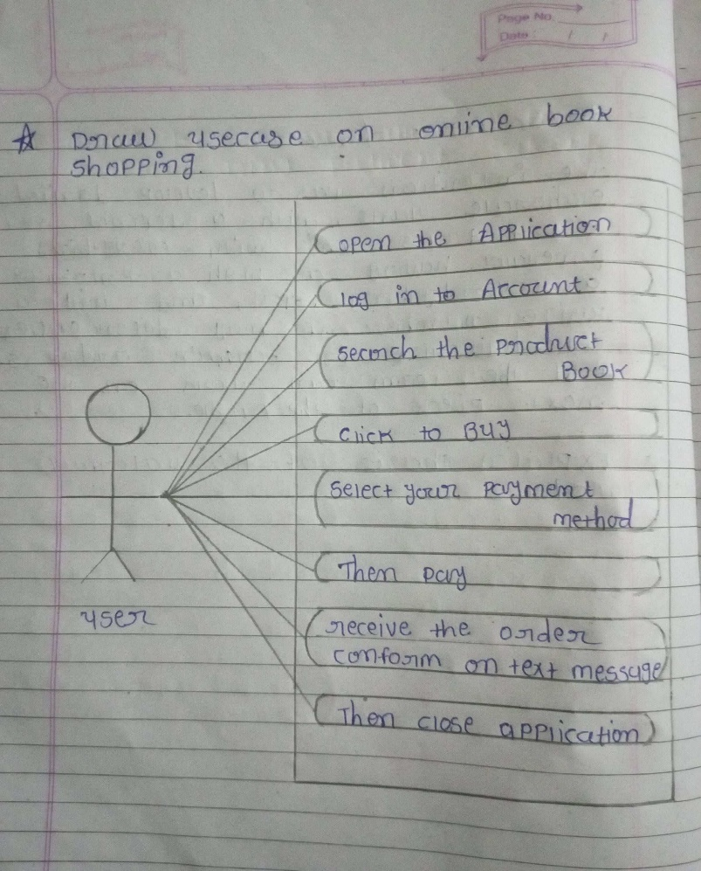

13) Draw Use case on online bill payment system (Paytm)

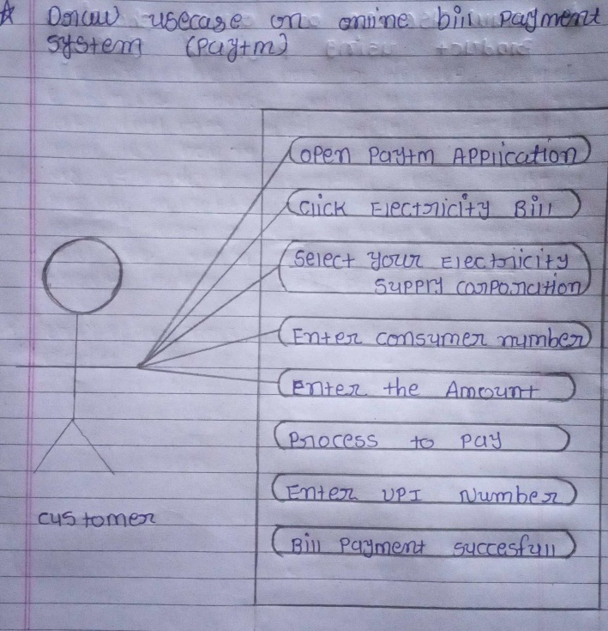

14) Write SDLC phases with basic introduction

* Requirements Gathering
* Analysis
* Design
* Implementation
* Testing
* Maintenance
* Requirements Gathering:

In SDLC the business analyst gathers the requirements and create development plan.

* Analysis:

The analysis phase also business requirements and identifies any potential risk.

* Design:

In this phase the requirement gathered in the document is used as an input and software architecture that is used for implementing system development is derived.

* Implementation:

The real code is developed and actual work takes place as per the design document.

* Testing:

In this phase the developed software is tested through and defects found are assigned to developers to get them fixed.

* Maintenance:

After the deployment of a product on the production environment, maintenance of the product.

15) Explain phases of the of the waterfall model

* Requirements collection
* Analysis
* Design
* Implementation
* Testing
* Maintenance
* Requirement gathering:

The first phase involves gathering requirements from stake holders and analyzing them to understand the scope and objective of the project.

* Analysis:

This is the most important phase in the SDLC as the goals is to understand the requirements of the new system and to develop a system that addresses these requirements.

* design:

This Involves creating a detailed design document, user interface and system components.

* Implementation:

This phase also includes unit testing to ensure that each component of the software is working as expected.

* Testing:

Testing verifies that the product developed in the implantation phase fulfills the entire product requirements.

* Maintenance:

Which involves fixing any issues that arise after the software has been deployed and ensuring that it continues to meet the requirements over time.

16) Write phases of spiral model

* Planning
* Risk Analysis
* Engineering
* Customer Evaluation
* Planning:

It includes estimating the cost schedule and resources for the iteration. It also involves understanding the system requirements for continuous communication between the system analyst and the customer.

* Risk analysis:

Identification of potential risk is done while risk mitigation strategy is planned and finalized.

* Engineering:

It includes testing, coding and deploying software at the customer site.

* Customer Evaluation:

Also includes identifying and monitoring risk such as schedule slippage and cost over rum.

17) write agile manifesto principles

* Individuals and interactions
* Working software
* Customer collaboration
* Responding to change

18) Explain working methodology of agile model and also write pros and cons.

* Pros.
* It is very realistic approach to software development
* Promotes teamwork and cross training
* Resource requirements are minimum
* Suitable for fixed or changing requirements
* Delivers early partial working solutions
* Functionality can be developed rapidly and demonstrated
* Little or no planning required easy to manage gives flexibility to developers
* Cros.
* Not suitable for handling complex dependencies.
* More risk of sustainability, maintainability and extensibility.
* Process is complex.
* More management attendance a required.
* Not a suitable for the short-term project.

19) Draw Use case on online shopping product using COD.

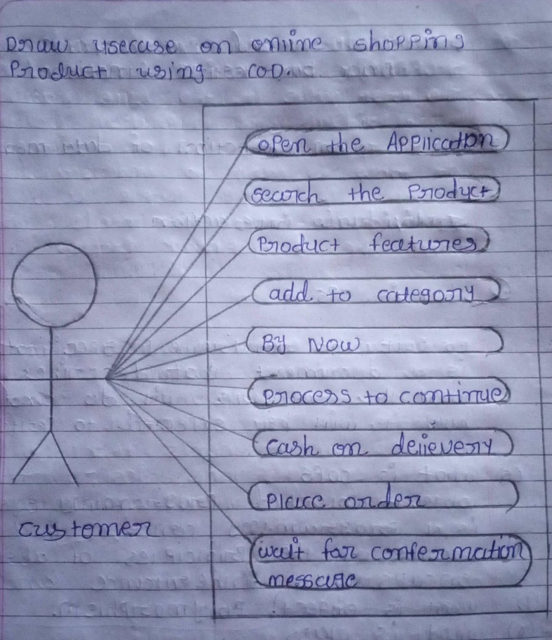

20) Draw Use case on online shopping product using payment gateway.

